Contact

Send you Cv’s to hr@mazco.com.sa

Or

Post Box: 2486, Dammam 31451,
KINGDOM OF SAUDI ARABIA.
Tell: +966 3 8260080 EXT: 31
Fax : +966 3 8266618
Website::www.mazco.com.sa

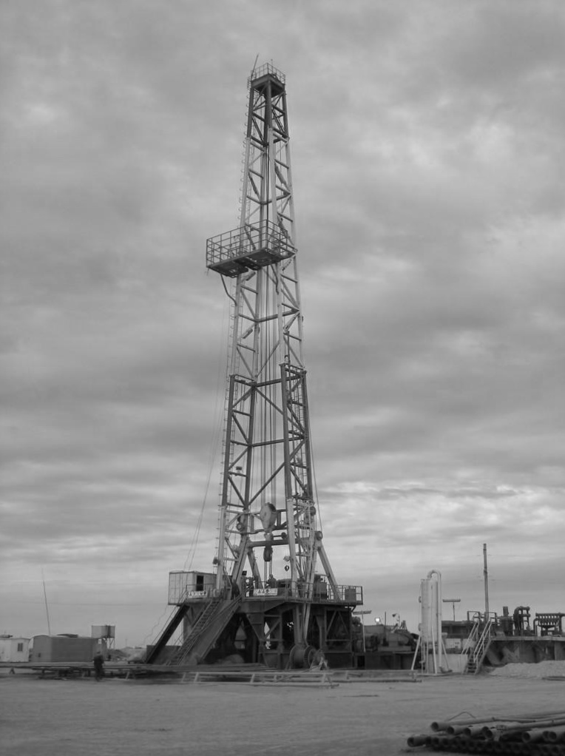

Rig Liaison man

Job Description:

Rig Liaison man shall:

    - Serve as the primary liaison between SAUDI ARAMCO and SAUDI ARAMCO rig Contractor and shall provide supervision of all operations performed on SAUDI ARAMCO wells.
    - Provide training and evaluation of SAUDI ARAMCO Liaison men/ Tool pusher trainees.
    - Make recommendations on alternative methods in resolving defects of equipment when unusual situations are encountered and coordinate timely deliveries of SAUDI ARAMCO and SAUDI ARAMCO Service Company materials and equipment to the well as required.
    - Ensure that SAUDI ARAMCO Contractors meet all contract requirements and shall verify and approve all SAUDI ARAMCO contractor and service company operations by way of tour reports and field tickets.
    - Ensure that SAUDI ARAMCO Contractors maintain the Rig and Equipment adequately to maximize efficiency and minimize down time, and that SAUDI ARAMCO materials and equipment are properly utilized, handled and stored and report to SAUDI ARAMCO for any misuse by Contractors of these materials and equipment.
    - Ensure that all SAUDI ARAMCO safety rules and regulations are followed by SAUDI ARAMCO Contractors and work with Drilling and Work over Engineers to see that modern practices are followed.
    - Work closely with SAUDI ARAMCO Drilling and Work over personnel as required accomplishing objectives and performing other miscellaneous duties as directed by the Drilling Superintendent.
    - Field Mentorship of trainees in the field development program (FDP).
    - Coordinate with the focal point for trainee’s requirement.
    - Train and instruct rig hands on job training (OJT) performance.
    - Mentor rig hands at rig site.
    - Assess competency for rig hands and identify gaps.
    - Transfer knowledge, skills and experience.
    - Prepare and conduct training courses.
    - Verify OJT and assess performance to acceptable standard (competency level).
    - Coordinate the training courses, personnel and logistics.
    - Evaluate gap assessment.
    - Compile assessments to SAUDI ARAMCO requirements and follow trainee’s progress.
    - Ensure trainee’s acceptable job standard level (skills and knowledge) under OJT plan.
    - Write and prepare stuck pipe/fishing technical courses.
    - Conduct class-room courses on stuck pipe and fishing.

- Follow up Drilling & Work over (D&WO) Operations on stuck pipe incidents, accustom courses contents to D&WO Operations.
- Diagnose stuck pipe and fishing problems and recommend solutions.
- Adapt course-specific objectives to follow current operations on practical-assigned locations.
- Consolidate course-topics for field assignment, explain, and review classroom teaching to provide guidance, support, and tutor trainee’s field progress.
- Identify trainee’s gap-knowledge and report to Professional Technical Training & Well Control Unit group leader and recommend solutions.
- Compile assessments according to SAUDI ARAMCO requirements and follow trainee’s progress.

Qualification:
  - BS in Petroleum Engineering, Mechanical Engineering or Electrical Engineering with seven (7) years of experience in drilling engineering and operations or High School Degree or equivalent with thirteen (13) years’ experience in Drilling Engineering and Operations.
  - Skill and expertise in deviated drilling including short radius horizontal wells.
  - Offshore jack up drilling experience with in depth knowledge of top drive units, Measurement While Drilling (MWD) technology and oil base muds.
  - Experience in drilling high pressure / high temperature wells as deep as 17,000 feet with heavy mud weights as high as 165 PCF in high H2S concentrations of 20%.
  - A current certificate in Blowout Prevention (BOP) and well control.
  - Have a valid Saudi driving license or a Saudi Arab Government acceptable international license to drive SAUDI ARAMCO vehicles.
  - Intensive oil/gas upstream specialized training courses with diploma education will be considered.
  - Extensive Drilling & Work over experience internationally (Shell, Exxon and Chevron etc.) as Rig Supervisor with both offshore and onshore drilling operations.
  - Extensive experience in mentorship and ability to transfer knowledge and skills.
  - Must have excellent communications skills.
  - Saudi Aramco field experience highly preferable.
  - Training and career development certified in English language.
  - Must have completed the H2S, Offshore survival (HUET), Firefighting and First Aid courses.
  - Must have completed the IADC certification courses to required level.

